Chemical reactions
- Chemical reactions always involve the formation of one or more new substances.
- Chemical reactions often involve a temperature change.
- Formulae are used to show the elements bonded together in a compound e.g. H₂O contains 2 hydrogen atoms and one oxygen atom.
- Compounds can only be separated into their elements by a chemical reaction
  - e.g. 2H₂O 2H₂ + O₂
- In chemical equations the three states of matter are shown as:
  - solid = (s); liquid = (l) and gas = (g)
  - aqueous solutions are shown as (aq)
  - e.g.
  - 2Na(s) + 2H₂O(l) → 2NaOH(aq) + H₂(g)
- An aqueous solution is a substance dissolved in water.
Relative formula mass
16
O
oxygen
8
- The relative atomic mass (A_{r}) is the average mass of the atoms of an element compared to the mass of carbon-12.
- The relative formula mass (Mr) of s substance is the sum of the A_{r} of all the atoms in the formula.
  - e.g. What is the M_{r} of water (H₂O)?
  - (A_{r} H = 1.0; O = 16.0)
  - There are 2 x H and 1 x O in the formula
  - (2 x 1.0) + (1 x 16.0) = 18.0
- A_{r} and M_{r} have no units as they are relative masses.
- In a balanced chemical equation:
  - sum M_{r} reactants = sum M_{r} products
  - e.g. 2H₂O₂ 2H₂O + O₂
  - Mr reactants = 2 x 34 = 68
  - Mr products = (2 x 18) + 32 = 68
- The percentage mass of an element in a compound can be calculated using the relative atomic mass and the relative formula mass.
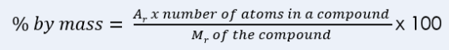

Conservation of mass and balancing equations
- No atoms are lost or made during a chemical reaction.
- mass of products = mass of reactants
- Chemical reactions can be represented by symbol equations which are balanced.
- This means the number of atoms of each element is balanced e.g.
- 2Mg + O₂ 2MgO
- there are 2 magnesium atoms on each side of the equation.
- Some reactions may appear to involve a change in mass, but this is normally because a reactant or a product is a gas e.g.
- Mg(s) + 2HCl(aq) MgCl₂(aq) + H₂(g)
- During the reaction hydrogen gas is produced. If the gas is free to leave the reaction container then the measured mass will decrease.

Uncertainty
- Scientific uncertainty means there is a range of possible values within which the true value of a measurement lies.​
- Whenever a measurement is made, there is always some uncertainty about the result obtained.
Concentration
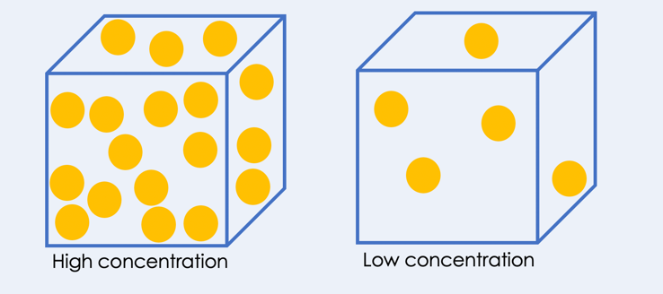
- Many chemical reactions take place in solutions.
- The more concentrated a solution the more particles it contains in a given volume.
- The concentration of a solution can be measured in mass per given volume of solution e.g. grams per dm³ (g/dm³).
  - mass of solute = concentration
  - volume of solution
- Volumes need to be in dm³
- 1 dm³ = 1000 cm³

Making soluble salts
- Soluble substances dissolve in a solvent
- Insoluble substances cannot dissolve in a solvent
- Neutralisation reaction general equation is acid + base → salt + water
- Metal + acid → salt + hydrogen
- Metal oxide + acid → salt + water
- Metal hydroxide + acid → salt + water
- Metal carbonate + acid → salt + water + carbon dioxide
- Soluble salts can be made from acids by reacting them with solid insoluble substances, such as metals, metal oxides, hydroxides, or carbonates.
- The solid is added to the acid until no more reacts and the excess solid I filtered off to produce a solution of the salt.
- Salt solutions can be crystallised to produce solid salts.
- Copper oxide reacts with sulfuric acid solution to produce copper sulfate and water
- This reaction can be represented with the equation CuO(s) + H₂SO₄(aq) → CuSO₄(aq) + H2O(l)
- Copper sulfate solution is a blue liquid
- Copper sulfate crystals are blue

